Additional Information and Resources
Login as cloud_user with the credentials provided. Make sure you are in us-east-1.
Three files can be downloaded from github here:
https://github.com/natonic/CloudFormation-Deep-Dive/tree/master/Labs/Condition%20Functions
Lab1_VPC.json is the "before" template. There is no condition in this template. If you want to try the challenge, adapt this template to add a parameter, a condition, and then a decision on tenancy based on the condition.
hints.json holds a couple of hints on configuring the condition if you need a little help.
vpctenancy.json is the solution template and can be used if you just want to follow along with the video walking through the solution.
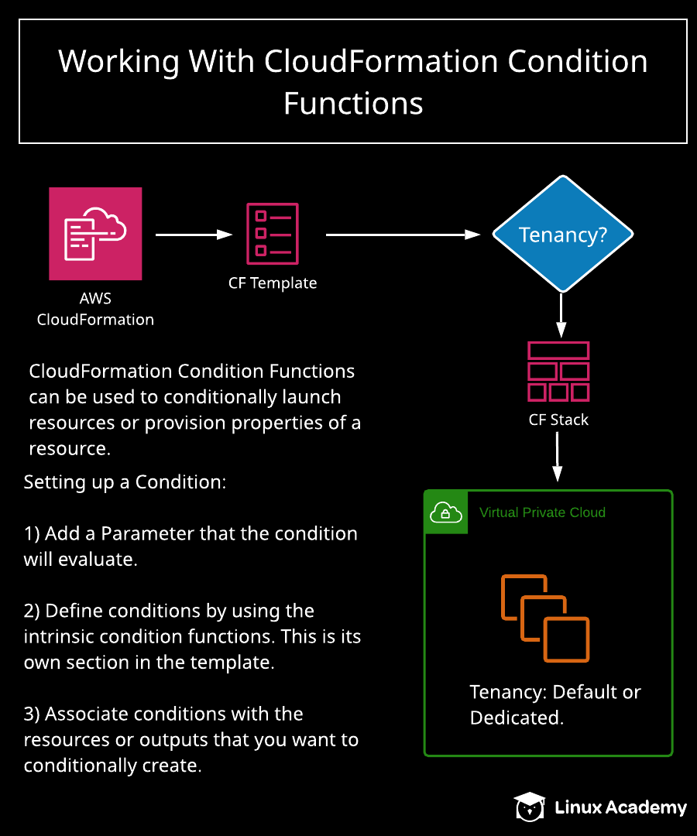

Working with CloudFormation Condition Functions

Introduction
This hands-on lab allows the student to create a condition function in a CloudFormation template. The condition function will determine if the VPC deployed by the template will be configured with default or dedicated tenancy. The student can either take the challenge of completing the lab without looking at the solution template, or they follow along with the solution offered in the second video.

Solution
- Before beginning the lab, download the .json files described on the lab page.
- Log in to the AWS Management Console using the credentials provided on the lab instructions page. Make sure you're using the us-east-1 region.

Create a Dedicated VPC
- Click CloudFormation.
- Click Create stack in the Stacks box.
- Under Specify template, select Upload a template file.
- Click Choose file.
- Navigate to the Lab1_VPC.json file previously downloaded and select it.
- Click View in Designer.
- Click the cloud button at the top to launch the stack wizard.
- Click Next.
- Under Stack name, enter "vpcdedicated".
- Click Next.
- Click Next.
- Click Create stack.
- Open a new tab and click Services at the top. Select VPC.
- Verify that you created a second VPC with dedicated tenancy.

Create a Dedicated VPC with a Conditional Parameter
- Go back to your original tab and click View in Designer.
- Add a parameter by adding the following text above the Resources section.
"Parameters": {
"Tenancy": {
"Description": "Set up VPC Tenancy",
"Type": "String",
"Default": "default",
"AllowedValues" : ["default", "dedicated"]
}
},
- Add a condition by adding the following text below the Parameters section.
"Conditions" : {
"VPCTenancy" : {"Fn::Equals" : [{"Ref" : "Tenancy"}, "dedicated"]}
},
- Replace the InstanceTenancy : "dedicated", line under Resources with the following.
"InstanceTenancy" : {
"Fn::If" : [
"VPCTenancy",
"dedicated",
"default"
]},
- Click the checkmark at the top to verify the template.
- Click the cloud button at the top to launch the stack wizard.
- Click Next.
- Under Stack name, enter "conditionDemo".
- Under Tenancy, select dedicated from the combo box.
- Click Next.
- Click Next.
- Click Create stack.
- Refresh the other tab viewing the VPCs.
- Verify that you created a third VPC with dedicated tenancy. In the original tab, you can click the Resources tab to get the ID for the VPC. Use that to verify the new VPC with dedicated tenancy.

Create a VPC with Default Tenancy Using the Conditional Template
- Click the template tab.
- Click View in Designer.
- Click the YAML option to view the template in YAML.
- Click the checkmark at the top to verify the template.
- Click the cloud button at the top to launch the stack wizard.
- Click Next.
- Under Stack name, enter "conditionDemo2".
- Under Tenancy, make sure default is selected in the combo box.
- Click Next.
- Click Next.
- Click Create stack.
- Refresh the other tab viewing the VPCs.
- Verify that you created a fourth VPC with default tenancy. In the original tab, you can click the Resources tab to get the ID for the VPC. Use that to verify the new VPC with default tenancy.

Conclusion
Congratulations — you've completed this hands-on lab!

